C:\Users\salman.aziz\Desktop\curemd-142-52.png

**10g App Deployment Checklist for QA**

|  |  |
| --- | --- |
| **Prepared by:** | **Abdul Wahab & Waqas Khalid** |
| **Reviewed by:** | **Mah Rukh** |
| **Version:** | **1.0.1** |

TABLE OF CONTENTS

1. Pre-Installations: 3

2. TFS Configuration: 4

3. Map and Get from TFS: 8

4. Copy/Paste in wwwroot: 9

5. Access Rights Verification: 9

Allow Full Rights 10

6. Component Services: 11

7. Config file Changes: 15

Miscellaneous points to remember: 21

## Pre-Installations:

1. SQL Server Installation 2008 or 2008 R2
2. IIS 7.5 or Up🡪 ASK Systems
3. Install Enterprise Library.

$/CMMI/SCM/CureMD-AddIns \Add-Ins-Installs\Enterprise_Library

**How to add DLL’s in Assembly?**

**(Ctlr+Mouse click on all below link to install on your machine.)**

1. Microsoft .Net Framework 1.1

$/CMMI/SCM/CureMD-AddIns \Microsoft .Net Framework 1.1

1. . Microsoft .Net Framework 3.5

$/CMMI/SCM/CureMD-AddIns \Microsoft .Net Framework 3.5

1. Microsoft .Net Framework 4.0

$/CMMI/SCM/CureMD-AddIns \Microsoft .Net Framework 4.0

1. Crystal Reports 2008🡪 ASK Systems
2. Install all Addins from below path:

$/CMMI/SCM/CureMD-AddIns \Add-Ins-Installs

1. Start menu > Run > Type ‘CMD’ and it will open command prompt.
2. Type *CD****<Space>****C:\Windows\Microsoft.NET\Framework\v4.0.30319*
3. *ASPNET_REGIIS.EXE****<Space> -****I* and Press **ENTER**.
4. *After installation of below path exe:*

$/CMMI/SCM/CureMD-AddIns \Add-Ins-Installs\J-Sharp-Redistribution

1. *GO to path: C:\Windows\Microsoft.NET\Framework\v2.0.50727 and copy these DLLs.*
2. **vjslib.dll**
3. **vjsnativ.dll**

And Paste on below paths:

* C:\Windows\Microsoft.NET\Framework\v4.0.30319
* C:\inetpub\wwwroot\CureMD\bin\

## TFS Configuration:

Setting up Team Foundation Server:

* 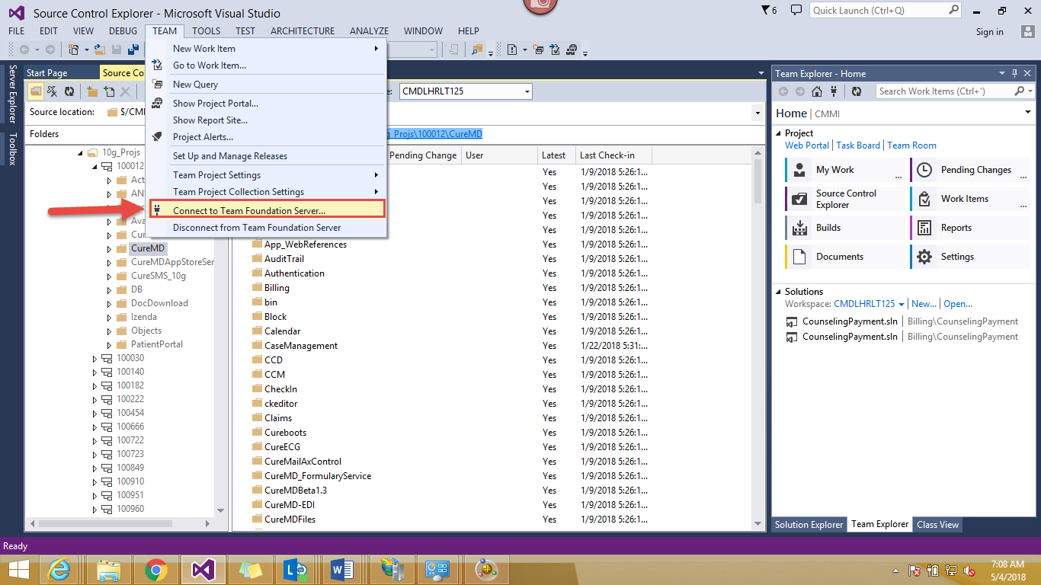Open Visual Studio 2013 and in top menu bar go to “Team” as shown in screenshot below
* In the drop down click on the option “Connect to team foundation server”
* On clicking, a window will open on right side with multiple options. Attached is the screenshot.

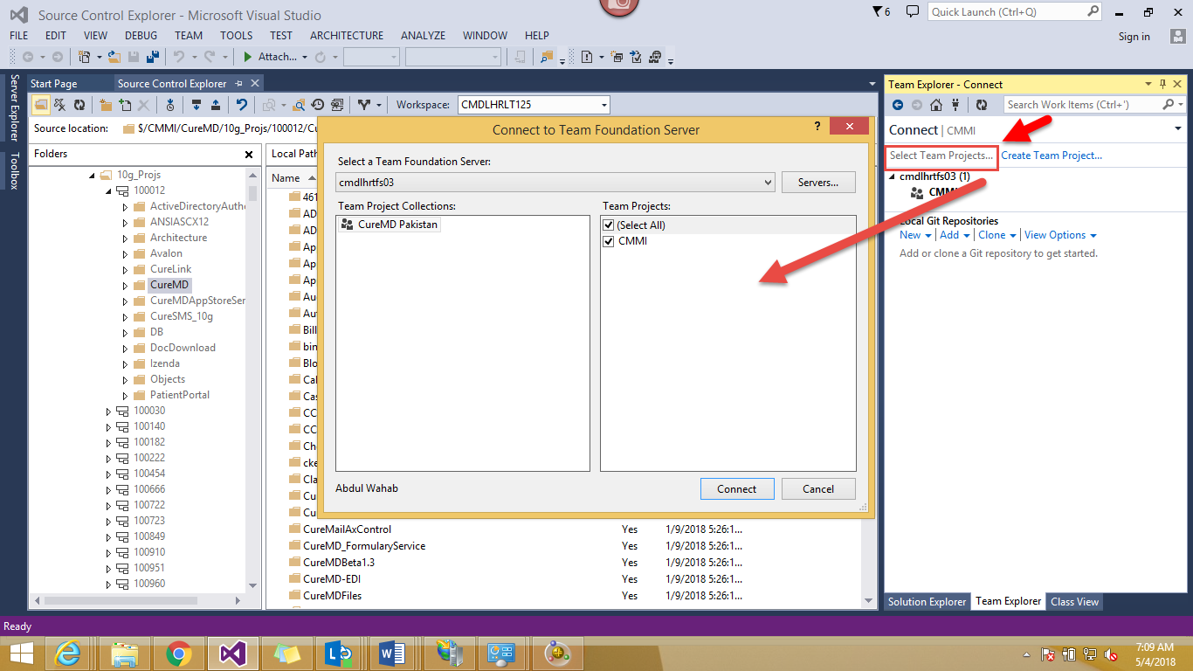

* Click on the option “Select Team Project”. A window will open. Now if you are first time user, you have to add the name of server you want to connect.

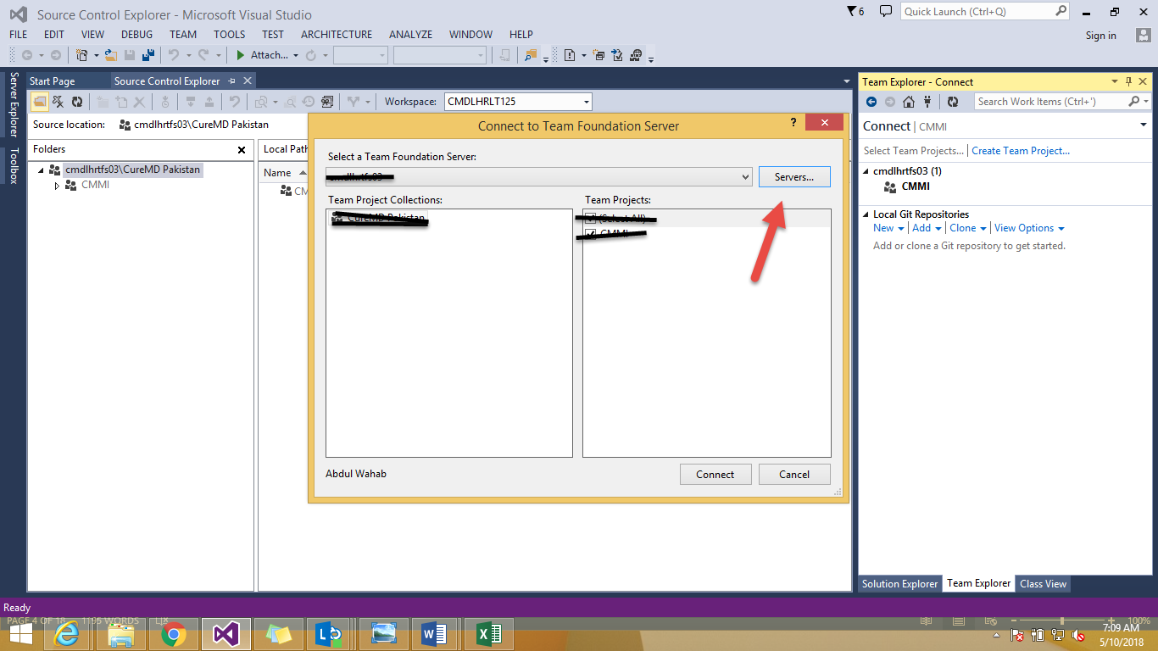

Click on “Servers” to add a server.

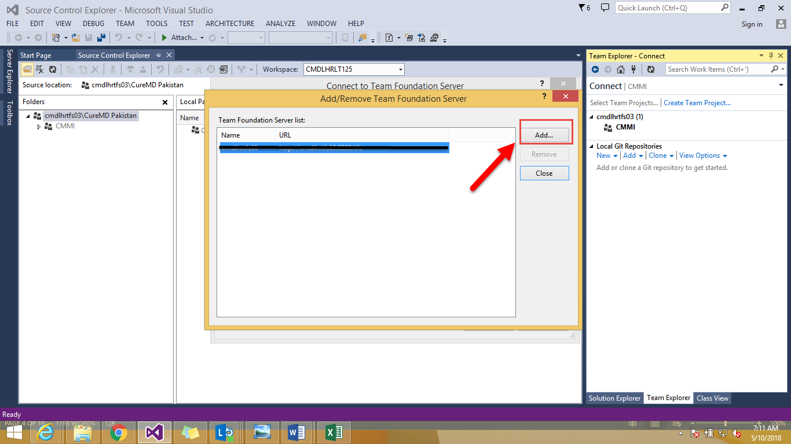

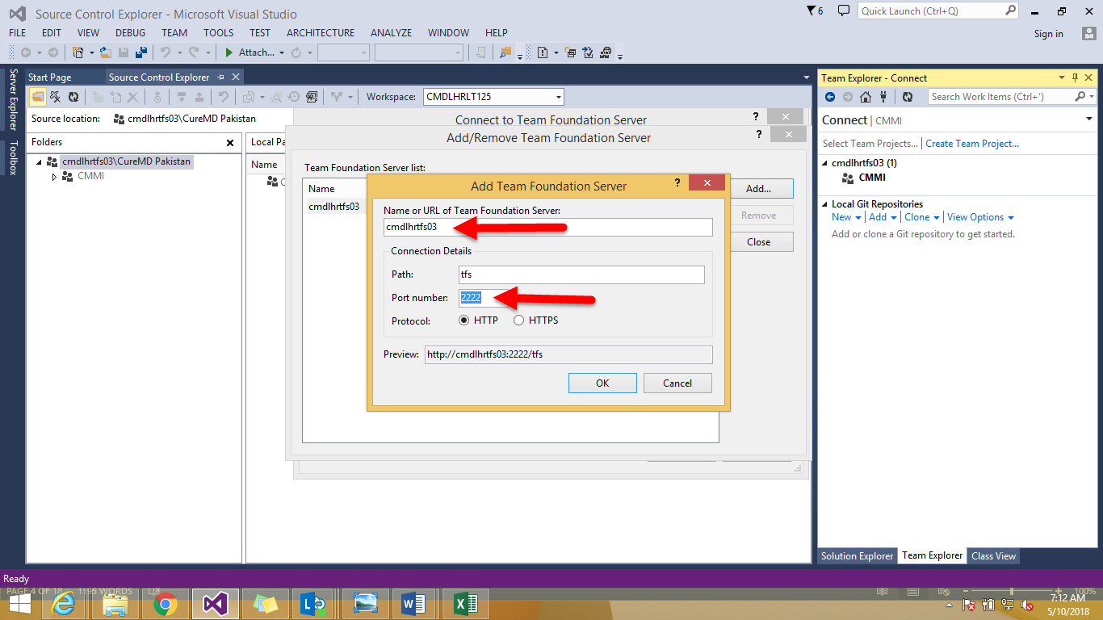

Give name “cmdlhrtfs03” and port number “2222”.



Click on “connect” button at bottom.

* 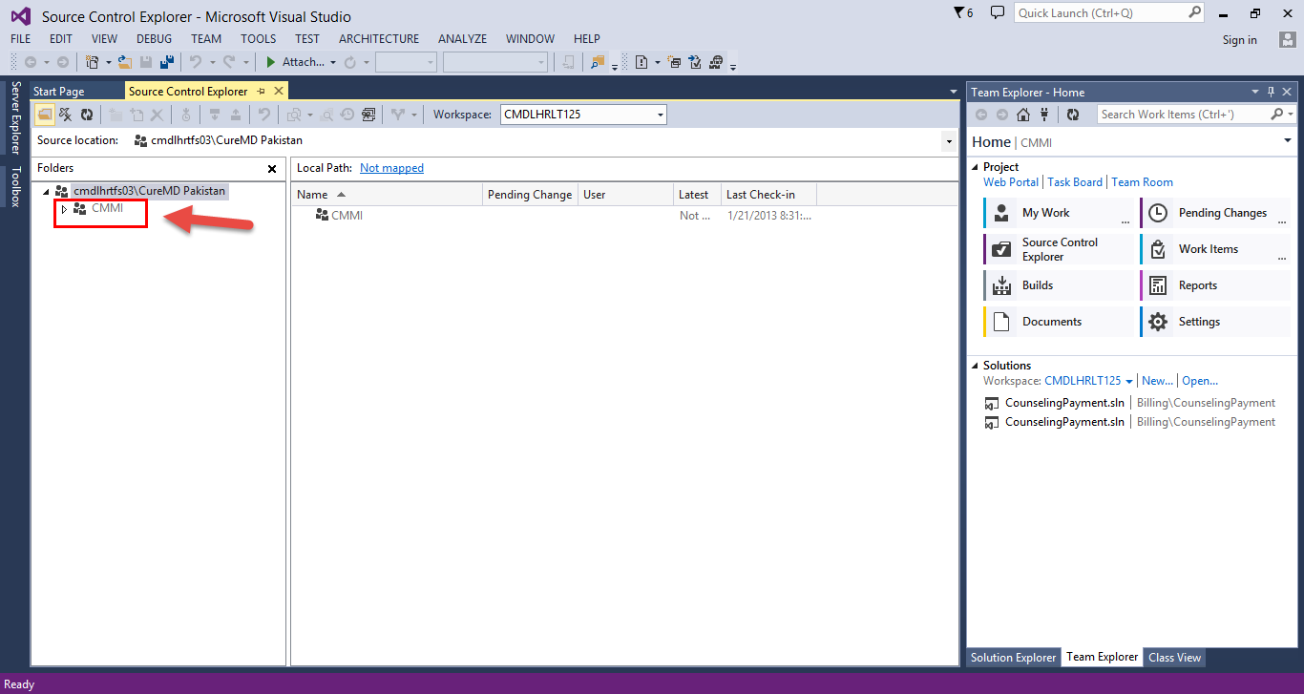After Loading you will see CMMI Option in the left menu. See Screenshot below.

**Configuration of TFS is done. Now we will see how to map a branch in local folder**

## Map and Get from TFS:

Expand the root node CMMI to get the drop down. You will see multiple options.

Follow the following pattern

**CMMI > CureMD > 10g_projs or Live Issues > Expand any branch > CureMD.**

* Right Click on the Last CureMD Folder and then Hover over “Advanced” and then “Map to local Folder”.
* Give the path of folder where you want to save the whole files and code. Usually we save it in D. One other option is to copy the whole Path in server name and paste it below with D appended in start. See the screenshot below.

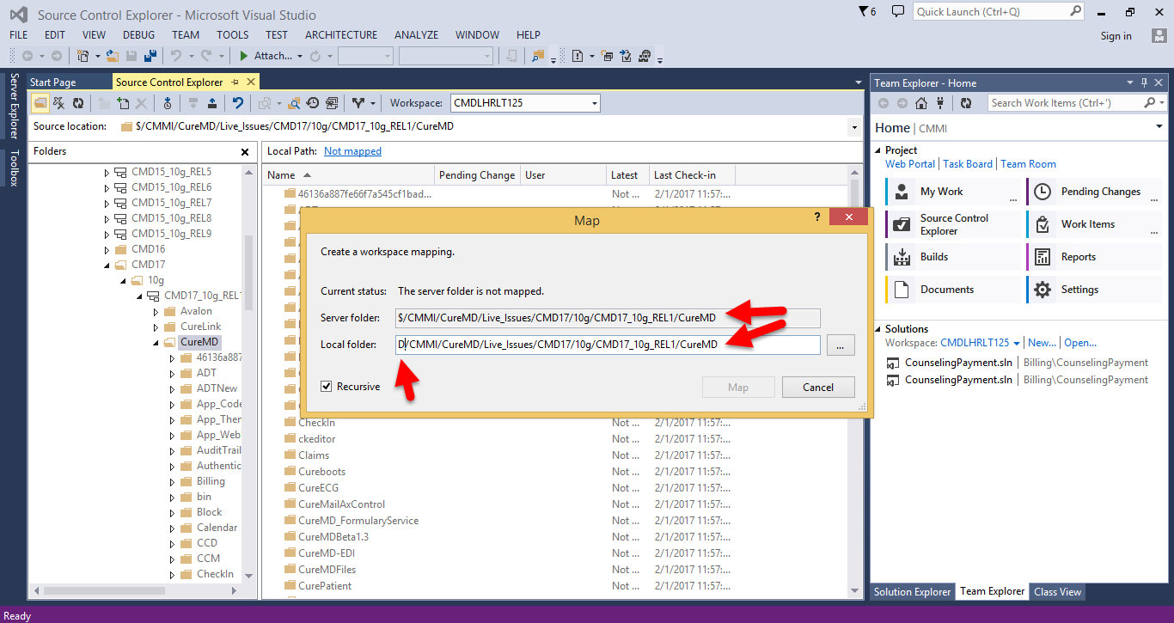

* Click on Map. You will see the bunch of items will start downloading.
* After all the items have downloaded, Right Click on the same folder you have just downloaded and go to “Get Specific Version”.
* Now all the source code and files have been mapped on to your machine on the path you have provided.

## Copy/Paste in wwwroot:

Go to the folder you have just downloaded on your machine, follow the tree and copy the last CureMD Folder on the following link.

C:\inetpub\wwwroot

## Access Rights Verification:

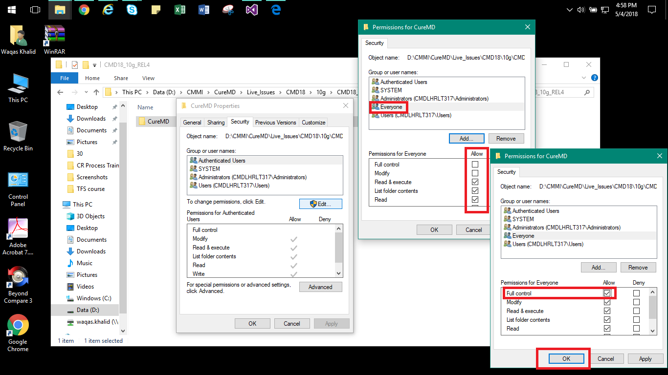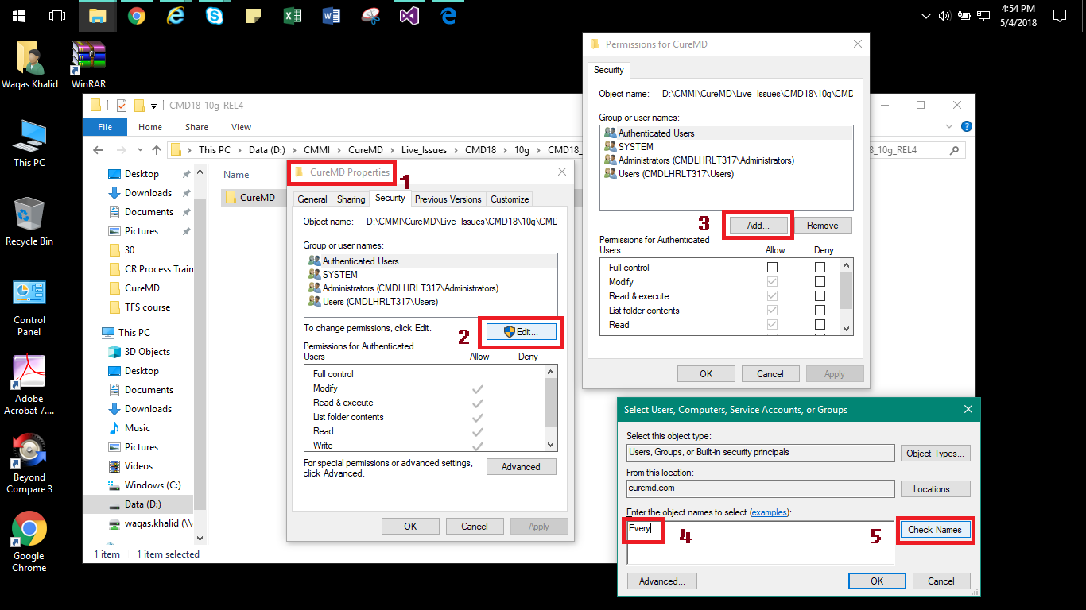Give access rights to below users in snap shot in D:\cureMD folder location:

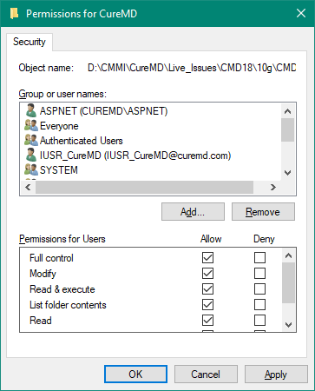

## Allow Full Rights

To the following:

* ASPNET (CUREMD\ASPNET)
* Everyone
* IUSR_CureMD ([IUSR_CureMD@curemd.com](mailto:IUSR_CureMD@curemd.com))
* Network
* Network Service
* IIS_WPG (CUREMD\IIS_WPG)
* Users (CMDLHRLT317\Users)

As you see the above Screenshot for **everyone** you have to add above mentioned list of users with full control.

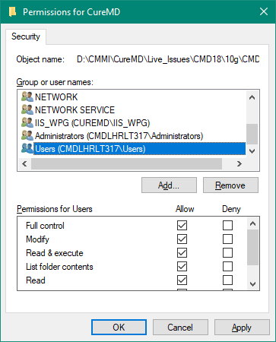

## Component Services:

1. Open Start and type component services.
2. If the folder doesn’t exist, then add the folder with name “CureMD_DLLs”
3. New > Application> Next > Create an Empty Application
4. Type ‘CureMD_DLLs’ and **Select** Server application
5. Press Next and Select



1. Next > Next > Finish
2. Right Click on **CureMD_DLLs** tab and select **Properties**> Security
3. Un-Check highlighted and **press OK**

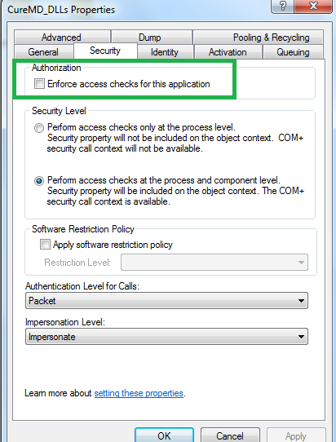

1. 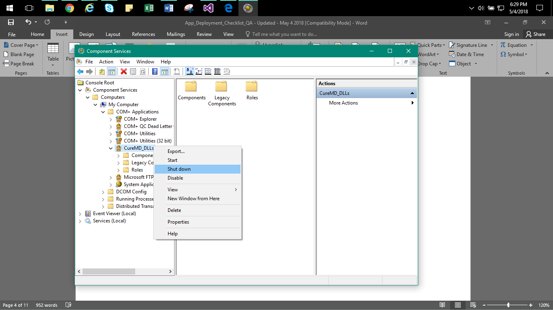Go to CureMD_DLLs as shown in Screenshot.
2. 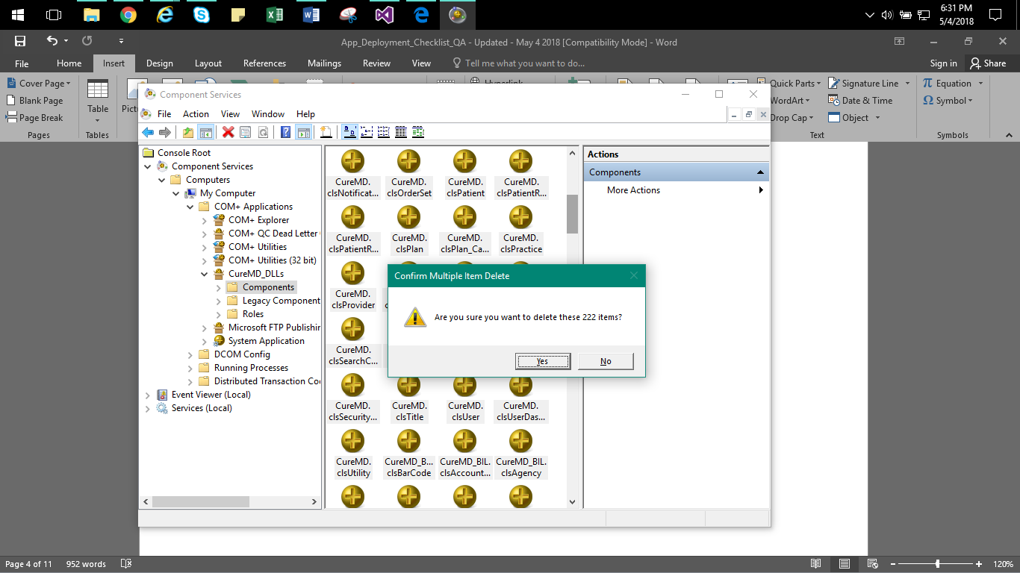Goto folder under CureMD_DLLs i.e. Components and select all files and delete it. If the folder is empty, then skip this step.
3. 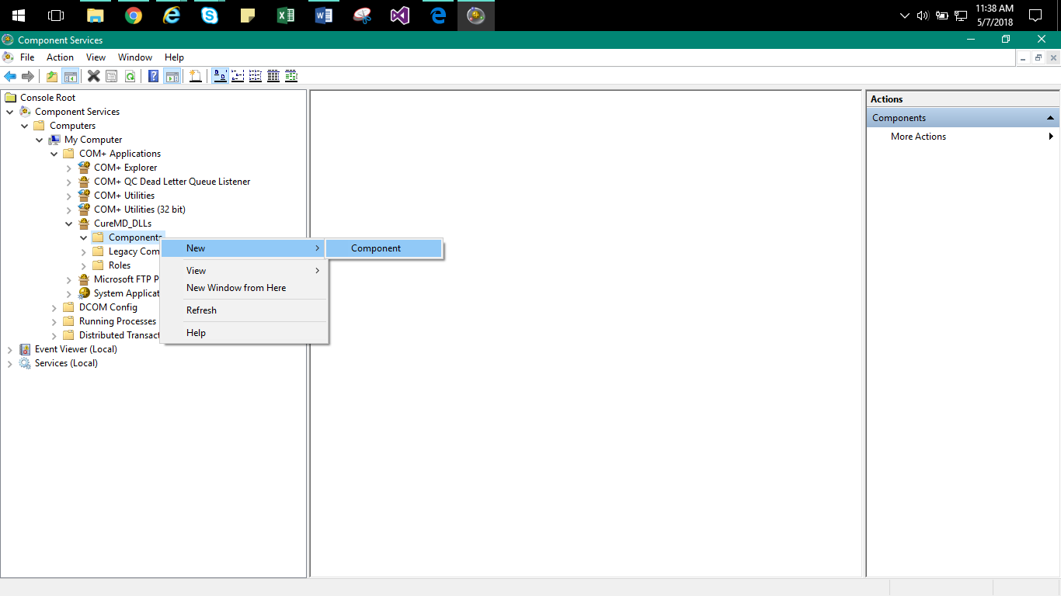After empty folder, now add the components. Follow below Screenshots one after one.

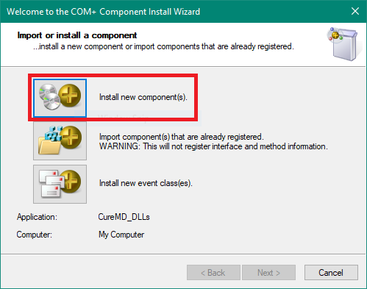

1. 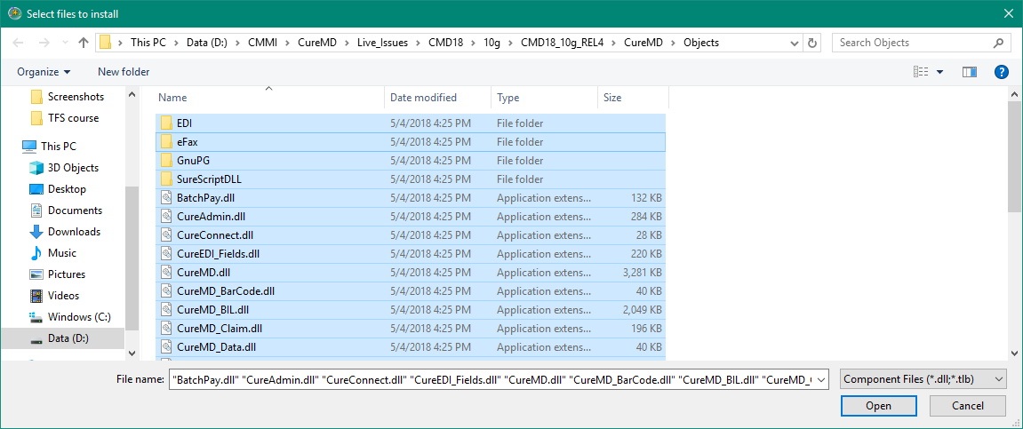Now navigate the path from where you want to extract a branch

CTRL+A

and

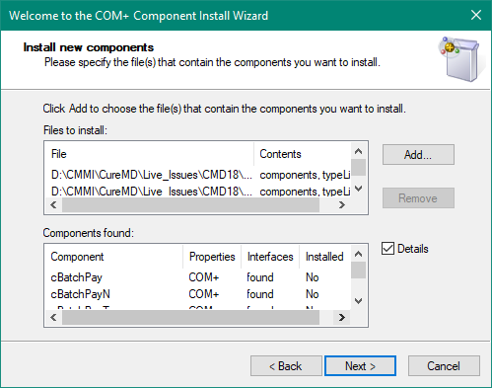

1. 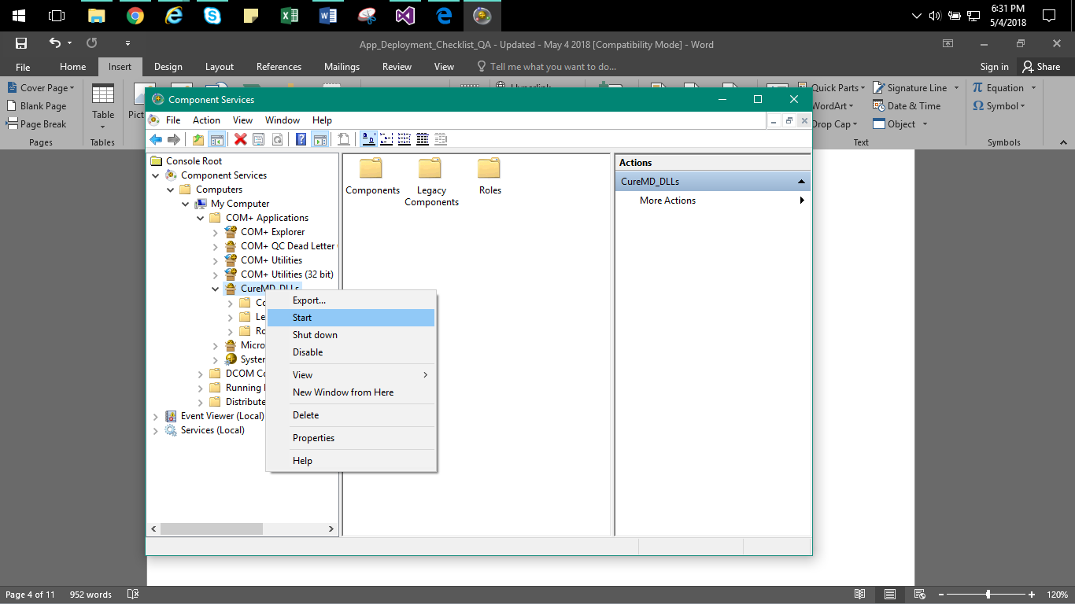After this process, start CureMD_DLLs again.

## Config file Changes:

Update the DB server name in CureMD.config placed at C:\inetpub\wwwroot\CureMD

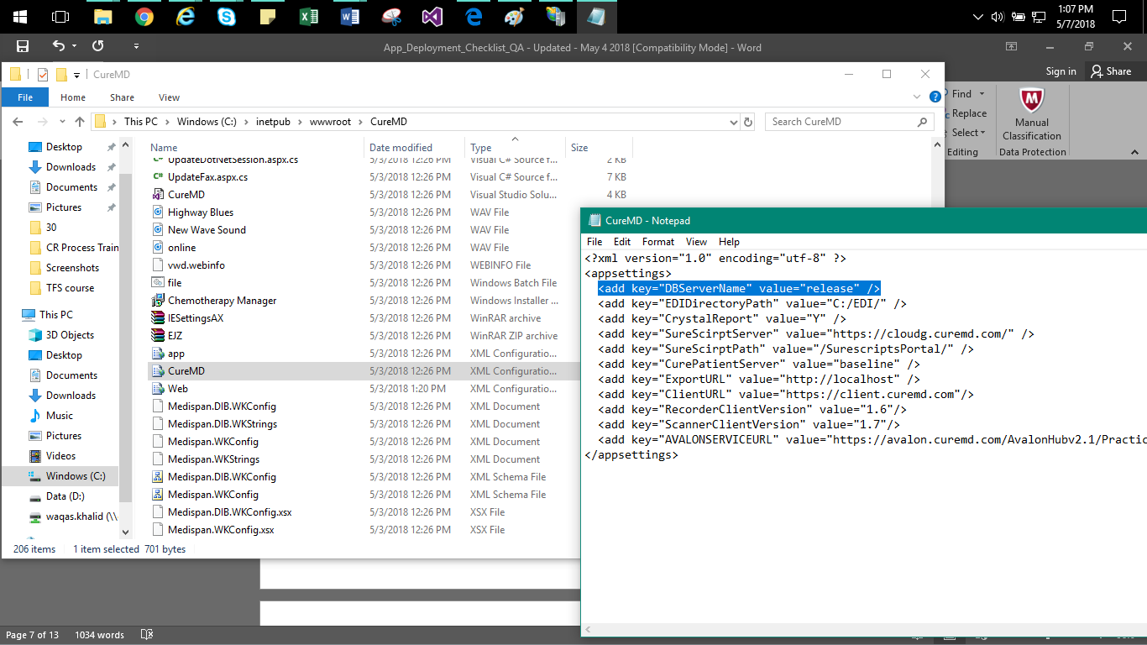**<add key="DBServerName" value=" cmdlhrsql01" />**

* In the RUN command type ‘inetmgr’ press enter.
* You will see the application folder in the left pane as shown below.

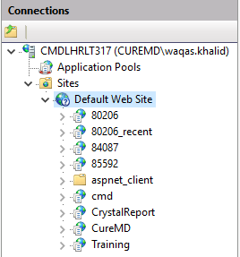

* Right click on “Default Web Site” hover on manage website -> Stop.

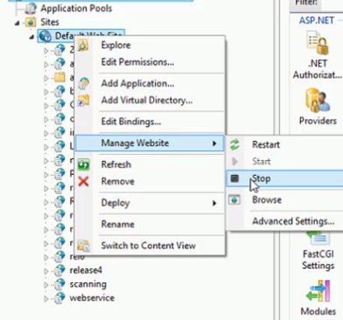

* Right click on “Default Web Site” again and select “Add Virtual Directory”.
* **Alias:** Training and **Physical path:** select the same dir where the CureMD folder you mapped. e.g. (D:\CMMI\CureMD\Live_Issues\CMD18\10g\CMD18_10g_REL4\CureMD)

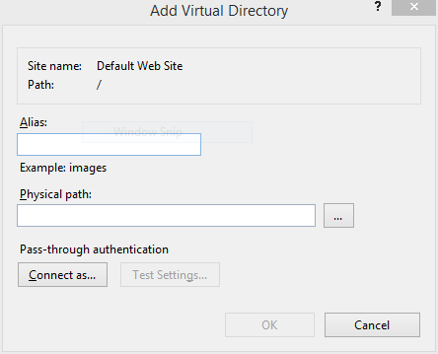

* Now Convert Virtual Dir to application. Right click on “Training” Dir and select Convert to application and add a POOL as .NET 4.5 Classic.

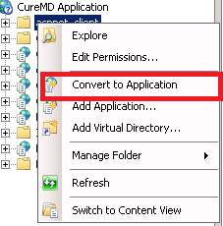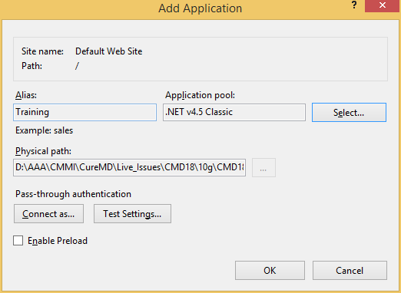

* Now see right side of the window and do the follow steps below with these two.

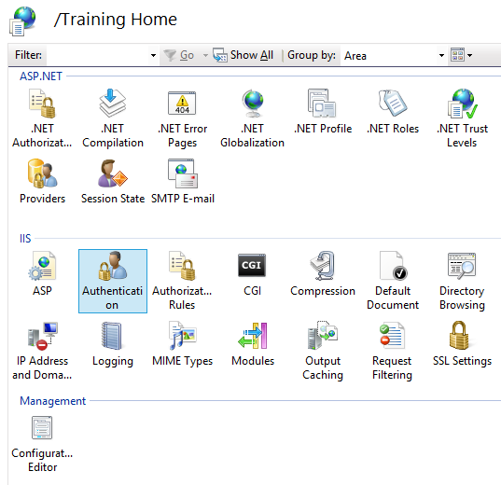

* 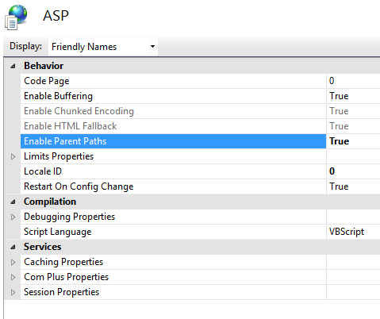Click on ASP and enable Parent path as True and enable Buffering as True.
* Now Click on Authentications and Enable every field in it except Forms Authentication.

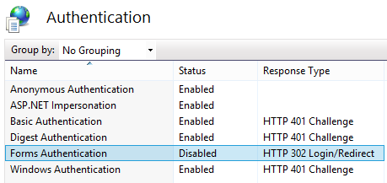

* 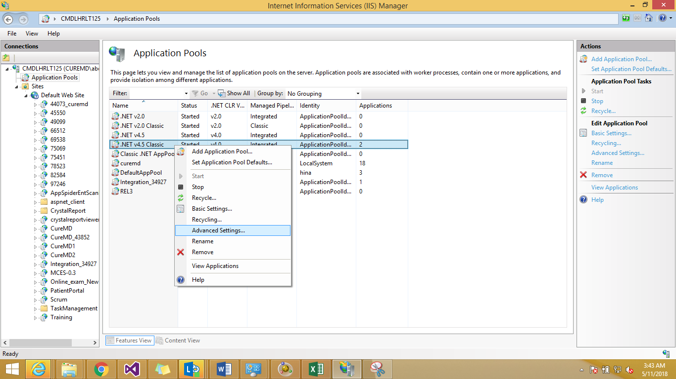Select Application pool then Select your pool and right click to select advance settings.
* Make sure the following highlighted things are same as mentioned in below snapshot.

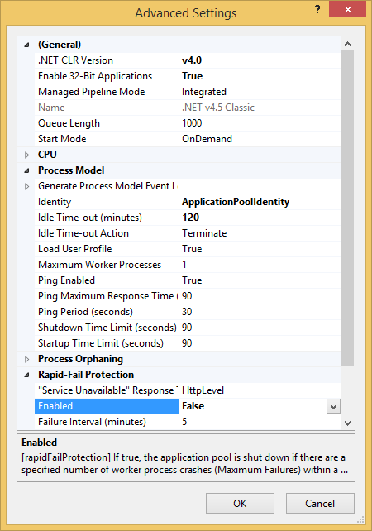

* Right click on “Default Web Site” hover on manage website -> Start.
* Now open IE and type in address bar **“http://localhost/Training/datlogin.asp”**

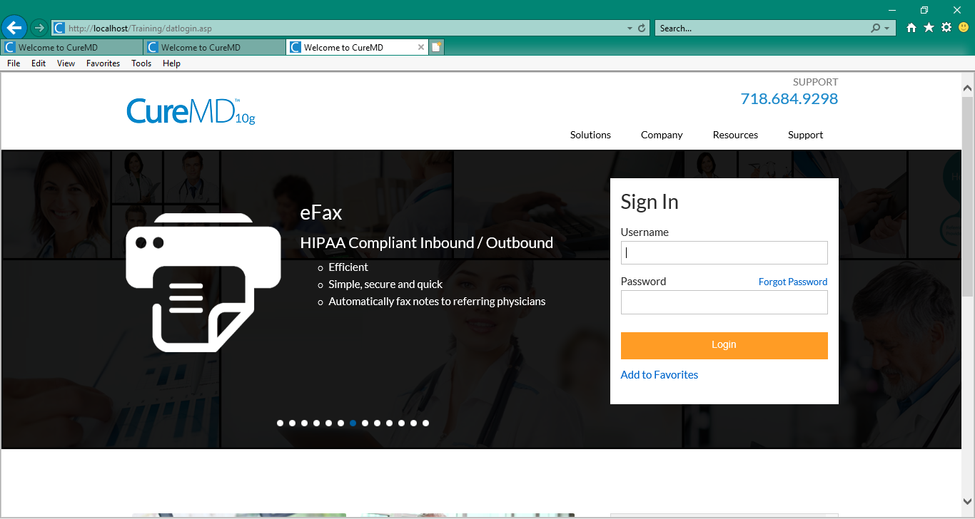

## Miscellaneous points to remember:

Give all rights to everyone on Temp folder **\Window\Temp**

Clear Temporary ASP.NET file on the following path

**\Windows\Microsoft.NET\Framework\v4.0.30319\Temporary ASP.NET Files**

Remove Read only flag from the **wwwroot** folder.

Copy all files from **inetpub\wwwroot\aspnet_client\system_web\2_0_50727** and paste it in to

**inetpub\wwwroot\aspnet_client\system_web\4_0_30319**

* Start -> Administrative Tools -> Services. **Start** and enable **Automatic** following service if it’s stopped and disabled.

Description: C:\Users\ali.nawaz\Desktop\3.GIF